Macrosystems EDDIE Module 8: Using Ecological Forecasts to Guide Decision Making - Student Handout



### Name: Whitney Woelmer

### Student ID: 123456789

#### Completed on: 2021-08-02 12:40:23

# Learning Objectives:

By the end of this module, you will be able to:

* Describe what ecological forecasts are and how they are used (Activity A)
* Identify the components of a structured decision (Activity A, B, C)
* Examine how an ecological forecast may affect decision-making (Activity B)
* Understand how stakeholder needs affect forecasting decision support (Activity B, C)
* Discuss how forecast uncertainty changes over time and how forecast uncertainty can be visualized for decision-makers (Activity A, B, C)
* Create visualizations tailored to specific stakeholders (Activity C)

# Why macrosystems ecology and forecasting?

**Macrosystems ecology** is the study of ecological dynamics at multiple interacting spatial and temporal scales (e.g., Heffernan et al. 2014). Macrosystems ecology recently emerged as a new sub-discipline of ecology to study ecosystems and ecological communities around the globe that are changing at an unprecedented rate because of human activities (IPCC 2013). The responses of ecosystems and communities are complex, non-linear, and driven by feedbacks across local, regional, and global scales (Heffernan et al. 2014). These characteristics necessitate novel approaches for making predictions about how systems may change to improve both our understanding of ecological phenomena as well as inform resource management.

**Forecasting** is a tool that can be used for understanding changes in macrosystems ecology. To anticipate and prepare for increased variability in populations, communities, and ecosystems, there is a pressing need to know the future state of ecological systems across space and time (Dietze et al., 2018). Ecological forecasting is an emerging approach which provides an estimate of the future state of an ecological system with uncertainty, allowing society to prepare for fluctuations in important ecosystem services. Ecological forecasts are a powerful test of the scientific method because ecologists make hypotheses of how ecological systems work; embed their hypotheses in models; use the model to make a forecast of future conditions; and then when observations are available, see how their forecast performed, which indicates if their hypotheses are supported. Consequently, macrosystems ecologists are increasingly using ecological forecasts to predict how ecosystems are changing over space and time. However, forecasts must be effectively designed and communicated to those who need them to make decisions in order to realize their potential for protecting natural resources.

The theme of this module is understanding how **forecasts are connected to decision-making of stakeholders,** or those who use forecasts to aid in decision-making**.**Ecological forecasts have vast potential for aiding decision-making for range of different stakeholders, yet forecast results may be challenging to understand because they inherently are associated with uncertainty in alternate future outcomes which have not yet occurred. This module will teach students the basic components of an ecological forecast; the importance of connecting forecast visualizations to stakeholder needs for aiding decision-making; and to create their own visualizations of probabilistic forecasts of ecological variables for a specific stakeholder.

# Module overview:

1. Introduction to Ecological Forecast Visualizations and Decision Support: Pre-readings and PowerPoint in class
2. Activity A: Explore ecological forecast visualizations
3. Activity B: Make decisions using an ecological forecast
4. Activity C: Create a cusotmized visualization for a specific stakeholder

# Optional pre-class readings and video:

* Dietze, M., & Lynch, H. (2019). Forecasting a bright future for ecology. *Frontiers in Ecology and the Environment*, *17*(1), 3.
* Spiegelhalter, D., Pearson, M., & Short, I. (2011). Visualizing uncertainty about the future. *Science*, *333*(6048), 1393–1400.
* Videos:
  + NEON's [Ecological Forecast: The Science of Predicting Ecosystems](https://www.youtube.com/watch?v=Lgi_e7N-C8E&t=196s&pbjreload=101)
  + Fundamentals of Ecological Forecasting Series: [Intro to Environmental Decision Making & PROACT](https://www.youtube.com/watch?v=ZLtzfAr90UE&list=PLLWiknuNGd50Lc3rft4kFPc_oxAhiQ-6s&index=19)

# Today's focal question:

## *How can ecological forecasts and their visualizations aid in decision making?*

To address this question, we will examine existing ecological forecasts to explore how decisions are made and how visualizations can be tailored to different stakeholders. We will be identifying the diversity of ecological variables currently being forecasted, as well as the different types of stakeholders and needs for making decisions with current ecological forecasts. We will also use output from a real water quality forecasting system to examine how uncertainty in forecast output changes over time, and how this can impact decision-making into the future. Lastly, we will explore how different ways of visualizing forecast output can be useful for different types of stakeholders of the forecast.

# Pre-Module Questions: Think about it!

Before starting Module 8, think through your experience using forecasts to make decisions and answer the following questions:

1. Name of a forecast that you have encountered.
2. How you do use this forecast to make decisions?
3. When are you more and less confident in using the forecast to make a decision?
4. What other groups of people do you think could use this forecast?
5. How do you access the forecast (e.g., through a website, app, etc.)?
6. How does the forecast represent the likelihood that the outcome will occur?
7. Would you be more confident in using the forecast to make a decision if you saw more or less information about the uncertainty?

# **As you go through the module, you will answer the questions below within the RShiny app and turn in your answers at the end of the activity for credit.**

# Activity A: Explore an existing ecological forecast

Many of us use various types of forecasts in our daily lives to make decisions (e.g., weather forecasts). However, we often take for granted the way in which the forecast is presented to us. In this activity, you will examine several ecological forecasts and analyze the visualizations they provide as decision-support tools for their users.

## **Objective 1: Explore how uncertainty is visualized in an ecological forecast**

Choose an ecological forecast visualization from the list of visualizations below.Spend a few minutes looking through all of the visualizations and then select one by clicking on the image. You should answer the questions below based on the image alone, but you can visit the website if you would like to learn more about the forecast.

1. What is the name of the forecasting system you chose?  
     
   **Answer:** Portal Rodent Forecasting
2. What ecological variable(s) are being forecasted?  
     
   **Answer:** rodent abundance in the desert
3. Does the visualization represent uncertainty? Please refer only to the figure within this app to answer this question. Do not use information from the website to inform your answer.  
     
   **Answer:** Yes
4. Is the visualization presenting forecast output or a forecast index?  
     
   **Answer:** Forecast output
5. Describe how the forecast is visualized (e.g., does it use words, numbers, icons, figures, etc. to represent its predictions?). If you answered ‘yes’ to Q3, make sure to also include a description of how uncertainty is visualized. If you answered ‘no’ to Q3, include a description of how uncertainty could be visualized.  
     
   **Answer:** it uses a figure in the form of a time series with a confidence interval. the uncertainty is represented by the confidence interval bounds on the prediction
6. Name one stakeholder who could use this forecast. This can be hypothesized by you or come directly from visiting the website.  
     
   **Answer:** a homeowner in the area might want to know if there will be a lot of rodents who could cause damage to their home
7. Classify the stakeholder identified in Q6 into a decision-use category that best fits their decision needs. If you need a refresher on the categories, go to the ‘Presentation’ tab and navigate to Slide 6 for category definitions.  
     
   **Answer:** Casual user

## **Objective 2: Compare forecast visualizations across forecasting systems**

With another team, compare forecasting systems and visualizations. Discuss the following questions regarding the ecological forecasting systems you explored.

1. What ecological variable was forecasted in your partner’s system?  
     
   **Answer:** atlantic sturgeon abundance
2. What are the major differences and similarities between the two system’s visualizations?  
     
   **Answer:** one is a forecast at one location over time and the other is a forecast at multiple locations at one point in time
3. Which visualizations represent forecast uncertainty?  
     
   **Answer:** Both
4. Does your partner’s visualization use a forecast index or forecast output?  
     
   **Answer:** Forecast index
5. Name one stakeholder who could use your partner’s forecast. This can come directly from the website or can be hypothesized by you.  
     
   **Answer:** a fisherman trying to reduce bycatch of this endangered species
6. Name one stakeholder who could use your partner’s forecast. This can come directly from the website or can be hypothesized by you.  
     
   **Answer:** the atlantic sturgeon forecast because it gives more detail about where the sturgeon is likely to be and translates it into a risk-level. it also has a more understandable type of uncertainty, where as the portal forecast has a huge range of uncertainty that isn’t helpful for making decisions

# Activity B: Make decisions informed by a real water quality forecast

Ecological forecasts have vast potential for aiding decision-making for range of different stakeholders, yet forecast results may be challenging to understand because they inherently are associated with uncertainty in alternate future outcomes which have not yet occurred. This activity will allow you to make decisions in order to optimize future drinking water quality. Forecasts will update through time, allowing you to see how forecast uncertainty changes over time, and how management decisions can impact water quality.

Read the following scenario and use it to complete Objecties 3-5.

**Scenario** : You and your partner are drinking water managers for the primary drinking water source reservoir for your city, which has ~300,000 residents. In 14 days, a major international swimming competition with an estimated ~2,000 participants will be held in the reservoir. As a result of hosting this event, the water utility will receive a direct bonus of >$3 million dollars from the city. However, the water utility is concerned about the reservoir’s water quality at this time of year, as historically there have been major algal blooms, which typically require expensive water treatment techniques. Without treatment, algal blooms can pose potential health issues to aquatic life, swimmers, and the city’s drinking water, which means you may have to cancel the swimming event if an algal bloom occurs. During the swimming competition, the water utility must continue to use the reservoir as a drinking water source, and so must balance the needs of maintaining safe water quality for drinking and swimming, ecological health of the reservoir, as well as the economic costs and benefits of treatment or holding the event.

Luckily, the reservoir was recently outfitted with a state-of-the-art water quality ensemble forecasting system. Every morning, managers receive a 14-day forecast of future algal concentrations in the reservoir, which are updated daily using sensors in the water. The forecast is ensemble-based meaning it produces 25 different forecasts of algal concentrations, allowing for uncertainty as to what will happen. Following local and national guidelines for beach closure, algal levels above 25 ug/L can be harmful for drinking without water treatment and detrimental to aquatic life, and levels above 35 ug/L are not suitable for human swimming.

As drinking water managers of the reservoir, you and your partner must decide how to manage the water quality in the reservoir every day over a 14-day period, using the forecasts as a guide. You can choose to continue with the event, cancel the event, or treat the reservoir with an algaecide. Algaecides are a management tool which decreases algal growth in the short-term but introduces harmful chemicals which can kill or harm aquatic organisms and can be dangerous to humans who come in direct contact with the water within 24-48 hours.

Each day as you look at the forecast you must optimize your three objectives, trying to keep all of them as high as possible. Your decision alternatives include:

1. Continue with the swimming event as planned.
2. Cancel the swimming event.
3. Treat the reservoir with an algaecide

## **Objective 3: Identify the components of the decision you need to make as a drinking water manager (PrOACT)**

1. Identify the components of the decision you need to make as a manager (PrOACT)
2. Problem(s):  
   **Answer:** You must optimize multiple objectives when managing the reservoirs at a time when algal blooms are likely
3. Objective(s):  
   **Answer:** Protect ecological health, Ensure swimmer safety, Provide safe drinking water, Maximize economic benefit
4. Alternative(s):  
   **Answer:** Treat the reservoir with an algaecide, Continue with the event, Cancel the event
5. Consequence(s):  
   **Answer:** Economic benefit is heavily decreased due to canceling the event, Compromised drinking water quality due to lack of treatment during an algal bloom, Decreased ecological health (e.g., death of aquatic organisms) due to algaecide treatment
6. Trade-off(s):  
   **Answer:** Decrease in ecological health, but safe drinking water is ensured, Swimmer safety is compromised, but economic benefit and ecological health remain high due to avoiding algaecide treatment, Small loss of money due to cost of algaecide, but increased economic benefit to the city from the event

## **Objective 4a: Decide how to manage a drinking water reservoir using an ecological forecast**

You now have access to the 14-day water quality forecast leading up to the day of the swimming event, June 6. Every day as time gets closer to the swimming competition, the forecast will update with new data, allowing you to update your decision. On each of the designated days, you must make a decision about whether to A) Continue with the swimming event as planned, B) Cancel the event, or C) Treat the reservoir with an algaecide. submit your answers below. Remember that the forecast includes 25 different ensemble members, which are different forecast estimates, and what you are seeing here is the mean of those ensembles.

As you make your decisions, remember that water becomes dangerous for drinking when the chlorophyll-a concentration goes above 25 ug/L and dangerous for swimming when the chlorophyll-a concentration goes above 35 ug/L.

***Days before the event: 14***  
What is the mean forecasted concentration for June 6 in the 14-day forecast?  
**Answer:** 26.5

In your own words, describe the forecast over the next 14 days leading up to June 6.  
**Answer:**

Decision 14 days before the event:  
**Answer:** C) Treat the reservoir with an algaecide

***Days before the event: 10***  
What is the mean forecasted concentration for June 6 in the 10-day forecast?  
**Answer:** 22.3

Decision 10 days before the event:  
**Answer:** A) Continue with the swimming event as planned

***Days before the event: 7***  
What is the mean forecasted concentration for June 6 in the 7-day forecast?  
**Answer:** 36.3

Decision 7 days before the event:  
**Answer:** C) Treat the reservoir with an algaecide

***Days before the event: 2***  
What is the mean forecasted concentration for June 6 in the 2-day forecast?  
**Answer:** 21.1

Decision 2 days before the event:  
**Answer:** A) Continue with the swimming event as planned

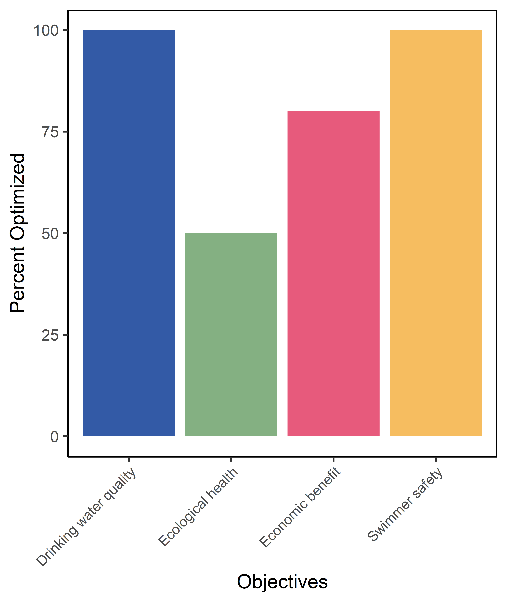  
*Figure 1. Plot of your Objectives Monitor from Activity B, Objective 4a.*

## **Objective 4b: Decide how to manage a drinking water reservoir using an ecological forecast which shows uncertainty**

Now, you will again make decisions about managing the reservoir over time, but this time you will use a different forecast visualization to make your decisions.

Examine the 14-day water quality forecast as you approach the day of the swimming event, June 6. The forecasts will update over time, allowing you to update your decision as the day gets closer. On each of the designated days, make a decision about whether to cancel the swimming event or not and submit your answers below.

***Days before the event: 14***  
Choose the best description of the forecast on June 6 from the following options  
**Answer:** There is a chance that the water quality will be dangerous to swimmers (>35 µg/L) on June 6

Decision 14 days before the event:  
**Answer:** A) Continue with the swimming event as planned

***Days before the event: 10***

Decision 10 days before the event:  
**Answer:** A) Continue with the swimming event as planned

***Days before the event: 7***  
Decision 7 days before the event:  
**Answer:** C) Treat the reservoir with an algaecide

***Days before the event: 2***  
Decision 2 days before the event:  
**Answer:** A) Continue with the swimming event as planned

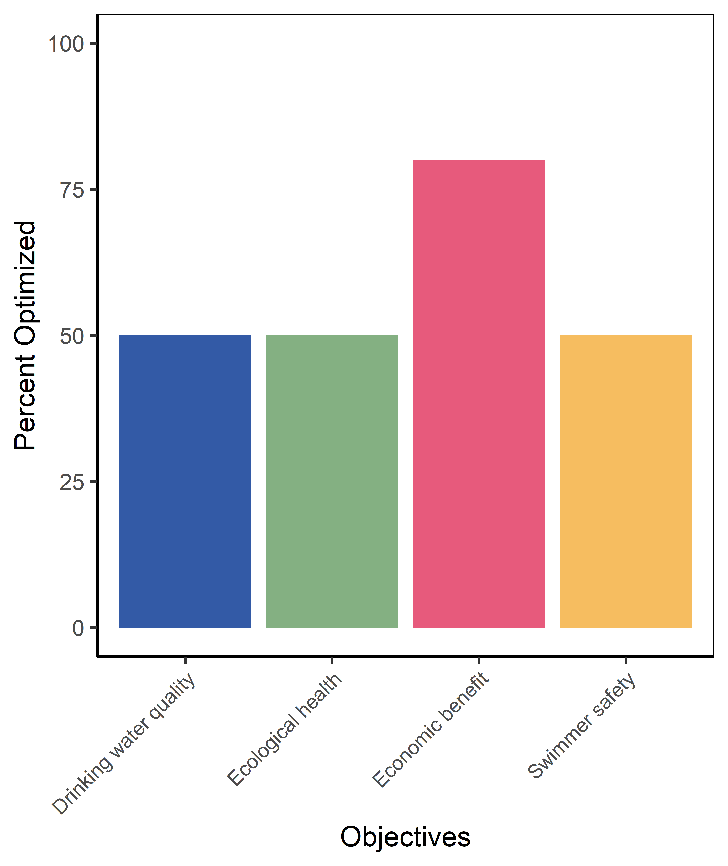  
*Figure 2. Plot of your Objectives Monitor from Activity B, Objective 4b.*

## **Objective 5: Assess the impact of the forecast visualization on your decision-making**

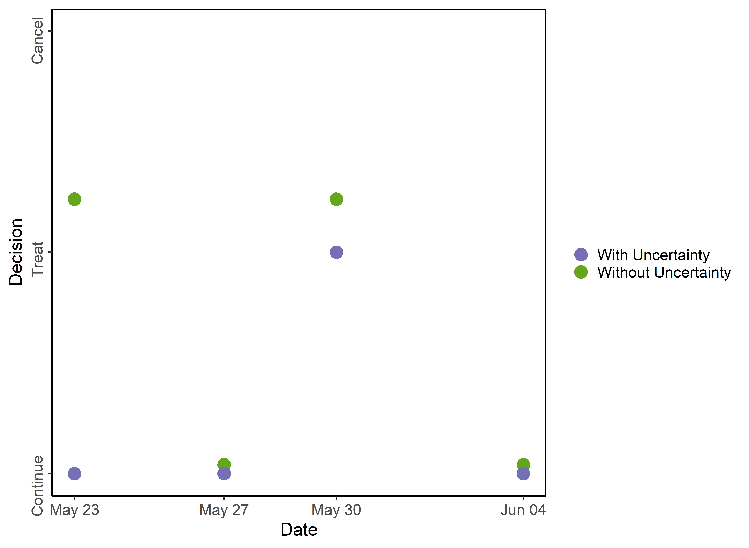  
*Figure 3. Plot of your decisions over time in Objective 4a and 4b*

1. What was the final algal concentration observed on June 6, if treatment had not occurred?  
     
   **Answer:** 27.6
2. Was the range of uncertainty around the forecast for June 6 (i.e., the difference between the highest and lowest predicted values) greater in the 14-day or the 2-day forecast?  
     
   **Answer:** 14-day forecast ranged from 9 to 50 ug/l, the 2-day forecast ranged from 20-35 ug/l
3. In this Activity, you made a decision about an event 2 weeks into the future. Based on your answer to Q16, do you think there would be more or less uncertainty around a forecast that was made for 2 months into the future?  
     
   **Answer:** there would likely be more uncertainty about an event 2 months into the future
4. Describe how your decisions were different between Objective 4a and 4b.  
     
   **Answer:** I was more conservative in objective 4b because I could see less of what was actually predicted to happen
5. What makes the visualization in Objective 4a different from Objective 4b?  
     
   **Answer:** 4b uses a forecast index while 4a uses a forecast output
6. Which of the four objectives were you most concerned with optimizing?  
     
   **Answer:** Drinking water quality
7. Which visualization did you prefer?  
   **Answer:** Objective 4a

# Activity C: Create a customized visualization of an ecological forecast for a specific stakeholder

Uncertainty is an inherently difficult concept to understand, and especially difficult to represent visually. There are many ways to represent uncertainty visually and it has been shown that different representations can lead to different levels of comprehension of the actual scenario. Further, the best way to visualize uncertainty is likely to vary between stakeholders, with some stakeholders needing more information than others in order to facilitate quick and accurate decision-making. This activity will allow you to role-play as a specific stakeholder, identify that stakeholder’s decision needs, and create a forecast visualization of uncertainty tailored to that stakeholder.

## **Objective 6: Identify a stakeholder and how they could use a water quality forecast for decision-making**

Using the same forecast as we used in Activity B to make decisions as a water quality manager, we will now customize the forecast visualization. It is important to consider who will be using your forecast to make decisions, as this can impact they way in which you visualize uncertainty.

**Choose a stakeholder from the drop-down menu and answer the questions below.**

**You have chosen:** Local Policymaker

1. Name one decision that your stakeholder could make if they were given a water quality forecast.  
     
   **Answer:** Decide whether or not to increase monitoring for a lake on a given day based on water quality levels
2. Classify your stakeholder into a decision-use category that best fits their decision needs. If you need a refresher on the categories, go to the ‘Presentation’ tab and navigate to Slide 6 for category definitions.  
     
   **Answer:** Decision analyst

## **Objective 7: Explore variability in the forecast output**

Below is a data table of forecast output of algal concentrations which you used in Activity B. In this activity, you will explore multiple ways of communicating this same forecast to create a customized forecast visualization for your chosen stakeholder.

**You have selected:**

1. What is the mean concentration of all the ensembles?  
     
   **Answer:** 29.4
2. What is the minimum concentration of all the ensembles?  
     
   **Answer:** 9.77
3. What is the maximum concentration of all the ensembles?  
     
   **Answer:** 50.8
4. What is one reason why there is uncertainty among these forecast estimates? (i.e., why are there so many different estimates here?)  
     
   **Answer:** uncertainty in how the weather will change over time

## **Objective 8: Create a customized forecast visualization for your chosen stakeholder**

Now that you are familiar with the forecast output from Objective 7, explore the following visualization options to make a customized visualization for your stakeholder.  
  
Your final visualization:

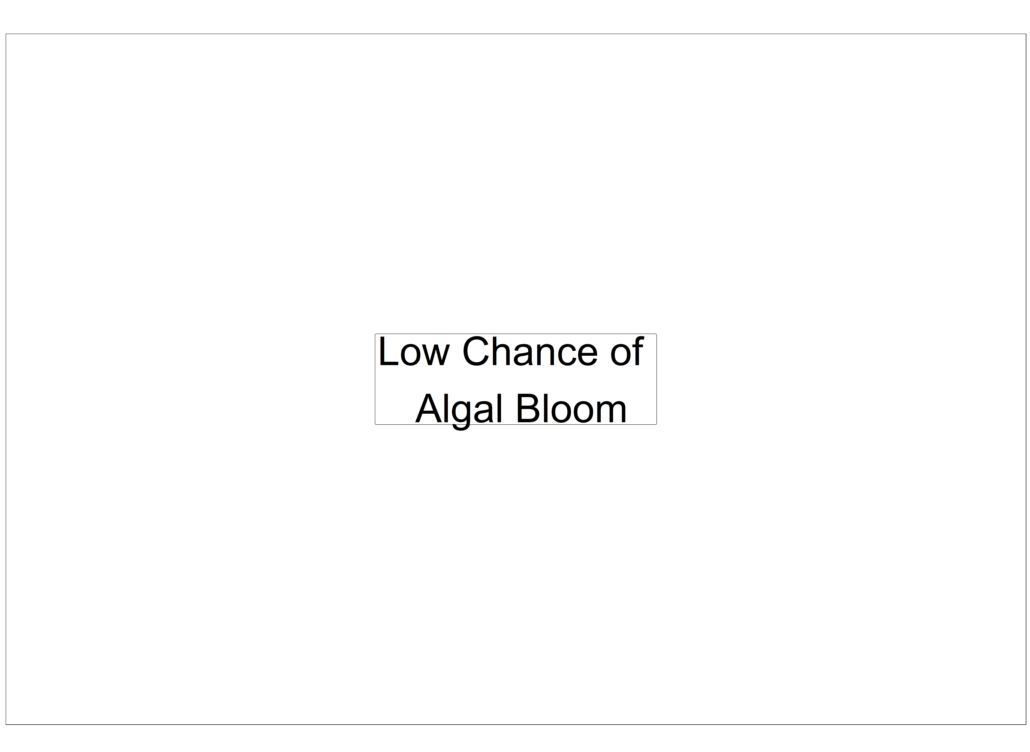  
*Figure 4. Custom plot made for Local Policymaker .*

Using your completed, customized visualization, answer the follow questions.

1. Why did you choose a forecast index or forecast output?  
     
   **Answer:** I chose a forecast output so that the stakeholder could have all possible information about uncertainty rather than specific to one type of metric
2. Why did you choose the communication type that you did (e.g., word, number, icon, or figure)?  
     
   **Answer:** I chose a figure to include as much information as possible
3. If you chose a figure representation, why did you choose the plot type that you did (e.g., pie, time series, bar graph)?  
     
   **Answer:** I chose a time series boxplot because it shows the distribution of the forecast over time
4. Pick one other stakeholder who could use a forecast of algal concentrations.  
     
   **Answer:** homeowner on a lake
5. What is the decision-use category of the stakeholder you identified in Q31?  
     
   **Answer:** Casual user
6. If you were customizing a visualization for this stakeholder, how might you alter your current visualization?  
     
   **Answer:** I would use a forecast index in order to condense the information into a succinct message

# Homework Bonus! Activity: Create your own forecast

Using what you've learned about connecting stakeholder needs to forecast visualizations, choose your own focal variable and identify the major components needed to create an ecological forecast of this variable.

1. Explain briefly how you would model your variable
2. What other variables are important to driving changes in your forecast variable?
3. How often a forecast will be made?
4. How far into the future the forecast will go?
5. What might influence uncertainty in your forecast?
6. Identify a stakeholder that could use this forecast to inform their decision-making,
7. Who is/are the relevant stakeholder(s) for your forecast?
8. What types of decisions they would need to make?
9. Identify the PrOACT components of their decision
10. Create a mock-up visualization of your forecast for your stakeholder  
      
      
      
    This module was initially developed by: W.M. Woelmer, T.N. Moore, R.Q. Thomas, and C.C. Carey. 21 January 2021. Macrosystems EDDIE: Using Ecological Forecasts to Guide Decision Making. Macrosystems EDDIE Module 8, Version 1. <https://serc.carleton.edu/eddie/macrosystems/module8>. Module development was supported by NSF grants DEB-1926050 and DBI-1922016.  
      
    This document last modified: 29 March 2021 by WMW.